Laptop RAM Workshop

Did you know that upgrading memory (RAM) in a laptop is one of the easiest and cheapest things you can do to improve the performance of your laptop? The purpose of this workshop is to give you the skills and confidence to do this yourself. NOTE: Only do this with a PC laptop, not a Mac.

Things You'll Need
- A specialty small set of screwdrivers
- The ability to look something up on the Internet
- Your phone camera

Step 1
Figure out the maximum RAM amount you can put in your laptop and the cost! Go to the ugrade section of a website such as https://www.crucial.com/upgrades (I am not endorsing this website over others that sell RAM.) Enter the manufacturer and model of your latop. This information can usually be found on the bottom of your computer, or else on the bezel (the part surrounding the keyboard or screen).

Raise your hand to get checked off! ______

Step 2

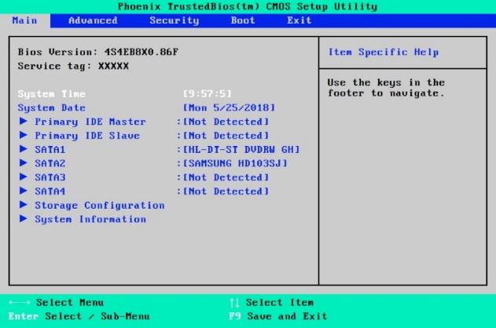 | How much RAM is currently in your computer? Turn the laptop on, and then immediately press F12 or F8. What you are trying to do is get into the laptop setup called the System BIOS. It may look like this picture.  Arrow around and press enter until you can see your RAM total. Do not make any other changes. Quit without saving and turn off the power.

Alternatively, on your computer, you might be able to find your RAM total by booting into Windows. Our workshop computers have no operating system installed, so we have to check this way.
Raise your hand to get checked off! ______
Step 3

Flip the laptop over so you can access the back. If your laptop has a small (almost square) door to unscrew, unscrew it. If your laptop does not, you may have to unscrew the entire back. Take pictures.

Raise your hand to get checked off! ______

Step 4
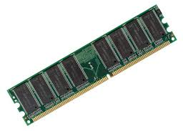
Remove the RAM memory sticks from the DIMM slot(s). These slots typically have a plastic latch on each side that must be snapped open before the memory sticks can be pulled out. It usually works better to pull the memory sticks out one side at a time. Here’s an example of what a RAM stick might look like:

Raise your hand to get checked off! ______

Step 5
Put the whole thing back together, in reverse order. Weee! Test your computer at one of the testing stations by plugging it into power, monitor, and keyboard. Hopefully it boots…

Raise your hand to get checked off! ______

